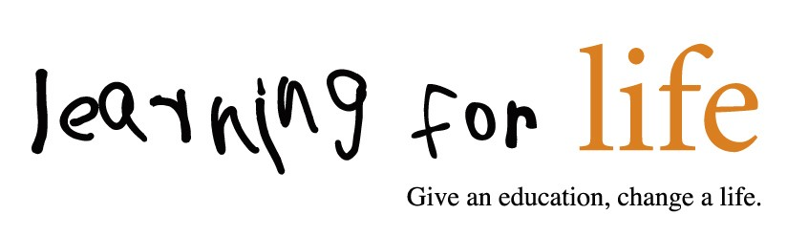

Privacy Policy
At Learning for Life, we’re committed to protecting and respecting your privacy.
This Policy explains when and why we collect personal information about people who visit our website, how we use it, the conditions under which we may disclose it to others and how we keep it secure.
We may change this Policy from time to time so please check this page occasionally to ensure that you’re happy with any changes. By using our website, you’re agreeing to be bound by this Policy.
Any questions regarding this Policy and our privacy practices should be sent by email to info@learningforlifeuk.org or by writing to Learning for Life, 24 Bedford Row, London, WC1R 4TQ

Who are we?
We are Learning for Life UK, (also known as LfL) an overseas development charity which works to provide education for children in south Asia. Learning for Life is a registered charity (no. 1105277) and company limited by guarantee (04662849). The registered address is 24 Bedford Row, London, WC1R 4TQ. Learning for Life does not have any trading subsidiaries or local groups in the UK.

How do we collect information from you?
We obtain information about you when you use our website, for example, when you contact us information about a project or to take part in an event, to make a donation or if you register to receive our newsletter.

What type of information is collected from you?
The personal information we collect might include your name, address, email address, IP address, and information regarding what pages are accessed and when. If you make a donation online, your card information is not held by us, it is collected by our third party payment processors, who specialise in the secure online capture and processing of credit/debit card transactions, as explained below.

How is your information used?
We may use your information to:
- process a donation that you have made;
- seek your views or comments on the services we provide;
- notify you of changes to our services;
- send you communications which you have requested and that may be of interest to you. These may include information about campaigns, appeals, other fundraising activities, promotions of our associated companies goods and services;
- process a grant or job application.
We review our retention periods for personal information on a regular basis. We are legally required to hold some types of information to fulfil our statutory obligations (for example the collection of Gift Aid). We will hold your personal information on our systems for as long as is necessary for the relevant activity, or as long as is set out in any relevant contract you hold with us.

Who has access to your information?
We will not sell or rent your information to third parties.
We will not share your information with third parties for marketing purposes.
Third Party Service Providers working on our behalf: We may pass your information to our third party service providers, agents subcontractors and other associated organisations for the purposes of completing tasks and providing services to you on our behalf (for example to process donations and send you mailings). However, when we use third party service providers, we disclose only the personal information that is necessary to deliver the service and we have a contract in place that requires them to keep your information secure and not to use it for their own direct marketing purposes. Please be reassured that we will not release your information to third parties for them to use for their own direct marketing purposes, unless you have requested us to do so, or we are required to do so by law, for example, by a court order or for the purposes of prevention of fraud or other crime.
When you are using our secure online donation pages, your donation is processed by a third party payment processor, who specialises in the secure online capture and processing of credit/debit card transactions. If you have any questions regarding secure transactions, please contact us.

Your choices
You have a choice about whether or not you wish to receive information from us. If you do not want to receive direct marketing communications from us about the vital work we do, then you can select your choices by ticking the relevant boxes situated on the form on which we collect your information.
We will not contact you for marketing purposes by email, phone or text message unless you have given your prior consent. We will not contact you for marketing purposes by post if you have indicated that you do not wish to be contacted. You can change your marketing preferences at any time by contacting us by email: info@learningforlifeuk.org,

How you can access and update your information
The accuracy of your information is important to us. To update your information please email info@learningforlifeuk.org
You have the right to ask for a copy of the information Learning for Life hold about you.

Security precautions in place to protect the loss, misuse or alteration of your information
When you give us personal information, we take steps to ensure that it’s treated securely. When you are on a secure page, a lock icon will appear on the bottom of web browsers such as Microsoft Internet Explorer.
Non-sensitive details (your email address etc.) are transmitted normally over the Internet, and this can never be guaranteed to be 100% secure. As a result, while we strive to protect your personal information, we cannot guarantee the security of any information you transmit to us, and you do so at your own risk. Once we receive your information, we make our best effort to ensure its security on our systems.

Profiling
We may analyse your personal information to create a profile of your interests and preferences so that we can contact you with information relevant to you. We may make use of additional information about you when it is available from external sources to help us do this effectively. We may also use your personal information to detect and reduce fraud and credit risk.

Use of 'cookies'
Like many other websites, the learning for Life website uses cookies. 'Cookies' are small pieces of information sent by an organisation to your computer and stored on your hard drive to allow that website to recognise you when you visit. They collect statistical data about your browsing actions and patterns and do not identify you as an individual. For example, we use cookies to store your country preference. This helps us to improve our website and deliver a better more personalised service.
It is possible to switch off cookies by setting your browser preferences. Turning cookies off may result in a loss of functionality when using our website.

Links to other websites
Our website may contain links to other websites run by other organisations. This privacy policy applies only to our website‚ so we encourage you to read the privacy statements on the other websites you visit. We cannot be responsible for the privacy policies and practices of other sites even if you access them using links from our website.
In addition, if you linked to our website from a third party site, we cannot be responsible for the privacy policies and practices of the owners and operators of that third party site and recommend that you check the policy of that third party site.

16 or Under
We are concerned to protect the privacy of children aged 16 or under. If you are aged 16 or under‚ please get your parent/guardian's permission beforehand whenever you provide us with personal information.

Transferring your information outside of Europe
As part of the services offered to you through this website, the information which you provide to us may be transferred to countries outside the European Union (“EU”). By way of example, this may happen if any of our servers are from time to time located in a country outside of the EU. These countries may not have similar data protection laws to the UK. By submitting your personal data, you’re agreeing to this transfer, storing or processing. If we transfer your information outside of the EU in this way, we will take steps to ensure that appropriate security measures are taken with the aim of ensuring that your privacy rights continue to be protected as outlined in this Policy.
If you use our services while you are outside the EU, your information may be transferred outside the EU in order to provide you with those services.

Review of this Policy
We keep this Policy under regular review. This Policy was last updated 9th May 2018.

